DEBYE RELAXATION TIME-AWARE SOC AND SOH ESTIMATION FOR LITHIUM-ION BATTERY FROM ELECTROCHEMICAL-IMPEDANCE-SPECTROSCOPY USING KLD-CoLU-DLSTM
Abstract: Precise estimation of the State of Health (SoH) and State of Charge (SoC) of lithium-ion batteries is fundamental for ensuring operational safety and maximum battery lifespan. However, the prior frameworks had overlooked the Debye Relaxation Time (DRT) of the lithium-ion batteries during the SOH estimation, thus obscuring the critical time-dependent relaxation behaviors. Therefore, this article proposes a DRT-aware approach for accurate SOC and SOH estimation in lithium-ion batteries using EIS and Kullback-Leibler Divergence Complementary Log-Unit Deep Long Short-Term Memory. (KLD-CoLU-DLSTM). Initially, the EIS data is collected and then pre-processed for noise removal. Next, the spectra are isolated, and then the isolated spectra are clustered based on the peak intensity. Subsequently, the Granger causality mapping is done, followed by peak feature extraction. Also, the DRT analysis is done by using the Foxholes Tikhonov Regularization Method (FTRM). Meanwhile, the voltage perturbation is analyzed from the pre-processed data. Additionally, the current density and overpotential are computed. Further, the dendrite formation is detected via Fick’s Law-based Diffusion Modelling (FL-DM). Also, the SOC is estimated. Based on the aforementioned factors, the labelling is done to predict the SOH. Finally, the proposed KLD-CoLU-DLSTM significantly classified the SOH as healthy, moderate, and aged with 98.94% accuracy.
Keywords: Lithium-Ion Battery (LIB), State of Charge (SoC), State of Health (SoH), Electrochemical Impedance Spectroscopy (EIS), Debye Relaxation Time (DRT), Electric Vehicle (EV), Machine Learning (ML), and Foxholes Tikhonov Regularization Method (FTRM).
- INTRODUCTION
With an increasing global demand for energy storage systems, battery technologies have gained immense popularity over recent years. Essentially, electricity sources like hydrogen fuel cells, lithium-ion batteries, lead acid batteries, lithium sulphur batteries, and nickel metal hydride are utilized to supply power to electronic applications, including Electric Vehicles (EV) (Kim & Kowal, 2021). However, Lithium-ion batteries are the most promising tool in various energy solutions owing to their beneficial natures, such as long service life, high energy density, and reliability (Iurilli et al., 2022). But, repeated charge or discharge cycles mainly affect the lifespan of the Lithium-ion cells. The nominal operational limit (70 to 80%) is considered to identify the aged lithium-ion cells that need to be exchanged (Chan et al., 2022).
Further, lithium-ion battery faces challenges like power density ratio limit drop and high internal resistance, resulting in decreased power delivery capacity (Ayob et al., 2022). Therefore, precise estimation of SOC and SOH aids in upgrading battery usage and battery monitoring systems, thereby increasing the battery lifetime (Zhang et al., 2021) (Kurzweil et al., 2022). SOC helps to measure how much charge is currently stored in the battery. Likewise, SOH reflects the battery’s ability to store electrical energy (Sun et al., 2023). The SOH plays a prime role in improving the overall condition of the battery, thus resulting in reliable energy solutions (Dini et al., 2024). Many of the engineers and researchers utilized Electrochemical Impedance Spectroscopy (EIS) to perform battery-related studies (Liu et al., 2023). EIS is a crucial scheme that provides detailed insights into charge transfer kinetics, such as ion diffusion and interfacial reactions (Mustafa et al., 2024).
Further, EIS effectively quantifies battery impedance in a wide frequency range, thereby tracking the internal aging stage of lithium-ion batteries (Zhang et al., 2023). Numerous studies were done to upgrade the battery management systems through a data-driven approach-based SOC and SoH estimation. Some of the existing methods established filter-based methods like the Kalman Filter to perform SOC estimation (Padder et al., 2025). Also, the existing methodologies introduced ML techniques, such as Neural Networks (NN) and Support Vector Regression (SVR), to accurately estimate the SOH of the lithium-ion batteries from EIS data (Thomas et al., 2025) (Fan et al., 2023). In the same manner, some of the prior studies established Deep Learning (DL) algorithms like Gated Recurrent Unit (GRU), Recurrent Neural Network (RNN), and Long Short Term Memory (LSTM) to perform EIS-based SOH estimation in lithium-ion batteries (Shao et al., 2025). However, none of the existing works concentrated on analyzing the DRT of the lithium-ion batteries during the SOH estimation, thus resulting in poor battery maintenance. Hence, this paper proposes an enhanced EIS-based SOC and SOH estimation framework for lithium-ion batteries using DRT analysis and KLD-CoLU-DLSTM.
  - Problem statement
The potential drawbacks of the existing studies are stated further.
- Essentially, DRT is one of the important factors in analyzing the SOH estimation of the battery. The conventional works failed to focus on the DRT of the lithium-ion batteries during the SOH estimation. As a result, less reliability and less accuracy were obtained.
- The prevailing work (Li et al., 2022) didn’t pay direct attention to recognizing the dendrite lithium formation in lithium-ion batteries, thus resulting in internal short circuits and capacity loss.
- The conventional approach (Ruan et al., 2021) failed to analyze the nonlinear relationships between voltage and SOC, thus increasing the risk of thermal runaway.
- The traditional model (Peng et al., 2023) struggled to distinguish the polarization processes due to the pseudo-random sequence, where the frequency bands overlapped.
- Many of the existing studies struggled to track the SOH of the battery accurately owing to the lack of empirical mapping, where the spectrum peaks were mapped to the battery’s aging processes, such as lithium plating or electrolyte degradation.
- Some of the conventional frameworks had a maximum risk of Solid Electrolyte Interphase (SEI) layer growth due to the voltage perturbations during charging or discharging, thus compromising battery reliability.
  - Objectives
The major goals of the proposed approach are given below,
- The proposed work introduces the FTRM to analyze the DRT of the lithium-ion batteries, thereby enhancing the precision of the SOH estimation.
- In the proposed work, a novel FL-DM is established to identify the presence of dendrite lithium formation, thus improving the model’s performance.
- A robust Hermite Interpolation Extended Kalman Filter (HI-EKF) effectively estimates the SOC of the lithium-ion batteries while handling the non-linear relationships.
- In the proposed work, frequency isolation and peak-intensity-based clustering are done, thereby enhancing the battery performance. An effective Lunacek Short Term Fourier Transform (L-STFT) is employed to isolate the frequency spectra. Likewise, a novel Gauss-Kuzmin distribution Maximum Shifting correlation K-means clustering (GKMSK-means) efficiently groups the spectra according to the peak intensities.
- The proposed work employs the Granger causality (GC)-based mapping to capture the rich spectrum-related features. Subsequently, the peak-based feature extraction is done to track the SOH in a precise manner.
- An enhanced Cosine Whitening Normalization Fuzzy Logic System (CWN-FLS) is introduced to evaluate the voltage fluctuations of the lithium-ion battery during charging or discharging.
The draft of this article is organized as follows: Section 2 investigates the associated frameworks for SOH estimation, Section 3 explains the proposed methodology with novel approaches, Section 4 evaluates the performance of the research framework, and Section 5 concludes the paper with future enhancement strategies.
- RELATED WORKS
(Li et al., 2022) suggested an effective framework called EIS-based SOH prediction for lithium-ion batteries. Initially, the input EIS data was fed into the Convolutional Neural Network (CNN), where the key points were extracted. Thereafter, the Bidirectional Long Short Term Memory (BiLSTM) model was established to estimate the SOH. Moreover, an improved Particle Swarm Optimization (IPSO) technique was introduced to optimize the neural network parameters. This work effectively prevented thermal runaway and overcharging by continuously monitoring battery health indicators. However, this framework failed to focus on analyzing the dendrite lithium formation, thus resulting in capacity loss.
(Ruan et al., 2021) propounded a multi-time-scale fractional-order model for lithium-ion batteries based on improved EIS. Here, an improved EIS-based multi-time scale fractional-order scheme was employed to simulate the dynamic behaviors (SOC) of the lithium-ion batteries in both time and frequency domains. This method had good flexibility, and it also allowed for timely maintenance. Nevertheless, this framework struggled to handle the nonlinear relationships between voltage and SOC, thus increasing the risk of thermal runaway.
(Peng et al., 2023) implemented a rapid impedance measurement framework for LIB based on the power spectrum property. Based on the power spectrum property of the injected signal, the battery impedance was calculated using a pseudo-pseudo-random sequence. Here, a Nyquist plot-based 3D cloud was reconstructed to clean the battery impedance. Thereafter, a statistics-based multiple-selection mechanism was used to eliminate the outliers. This framework accurately estimated the EIS without tampering with the original measurement. Overall, this framework helped to increase battery lifespan. However, this model was inadequate to capture the rich spectrum features due to the lack of feature band isolation.
(Mc Carthy et al., 2022) demonstrated a well-ordered scheme named EIS correlation analysis-based capacity estimation of LIB. This work focused on estimating the SOC, SOH, and internal temperature of the batteries. To measure the degree of dependence, correlation analysis was done between equivalent circuit elements and impedance spectra with respect to numerous SOC, SOH, and internal temperature levels. Also, curve fitting techniques were utilized to fix the impedance spectra in the equivalent circuit model. Further, Pearson’s correlation matrix was used to quantify the degree of correlation between the state parameter and each impedance variable. Based on the dependence value, the SOC, SOH, and internal temperature were estimated. This framework had a high battery management system efficiency. Nevertheless, this approach had poor generalizability.
(Li et al., 2023) examined EIS measurement and Transfer Learning (TL)-based SOH prediction of lithium-ion batteries. From the gathered EIS data, the essential features were extracted. Thereafter, the TL with Deep Neural Network (DNN) was utilized to estimate the SOH of LIB at various temperatures. This model had high adaptability and required limited samples owing to the presence of TL. However, this framework had over-fitting issues owing to the source-specific features.
(Buchicchio et al., 2023) investigated an EIS data-based battery SOC prediction framework using ML and an equivalent circuit model. Primarily, the exploratory data analysis was done to extract information about the lithium-ion batteries. Also, the equivalent circuit model was employed to transform the raw EIS data into various parameters. Subsequently, the battery feature set was created. Thereafter, ML algorithms like K-Nearest Neighbour (KNN), Naïve Bayes (NB), and Support Vector Regression (SVR) were used to estimate the SOC of the battery. This framework had low computational overhead. However, this model had limited adaptability to aging effects.
(Bourelly et al., 2023) designed a reliable scheme named accuracy and measurement time optimization based on SOC estimation using EIS data. Initially, the features were extracted from the EIS data. Then, the optimal features were selected by using optimization techniques like Genetic Algorithm (GA) and Particle Swarm Optimization (PSO). Finally, the classifiers, such as KNN, Random Forest (RF), and Support Vector Machine (SVM), were utilized to predict the SOC with minimum errors. Nevertheless, this approach failed to capture the time-domain behaviors, thus resulting in less reliability.
(Jin et al., 2025) developed SOC and lifetime prediction of lithium-ion batteries using extended equivalent circuit models. Initially, the Chebyshev coefficient was used to generate the high-dimensional vectors of the EIS data. Then, the Quasi-Monte Carlo (QMC) method was employed to categorize the battery’s health as fresh, aged, and dead. This framework effectively mitigated unplanned downtime. Nevertheless, this model was limited to capturing complex electrochemical dynamics.
(Xu et al., 2022) introduced a SOH and aging properties estimation model for retired batteries based on the EIS data. Primarily, the Equivalent Circuit Model (ECM) was generated. Then, the correlation analysis was done between ECM parameters and the battery age. Thereafter, the Bayesian neural network with automatic feature extraction was established to estimate the SOH effectively. But, this approach had a maximum error rate, thus degrading the model’s reliability.
(Huang et al., 2022) introduced extended Kalman filter-based SOC and SOH estimation. Here, the SOC and SOH of the lithium-ion batteries were estimated by using the piecewise equivalent circuit model based on the extended Kalman filter. This approach had low computational complexity and high real-world applicability. Nevertheless, this approach had suboptimal convergence owing to the inappropriate initial state estimation.
- PROPOSED SCHEME FOR DRT-AWARE ROBUST SOC AND SOH PREDICTION IN LITHIUM-ION BATTERIES USING KLD-CoLU-DLSTM
The proposed work implements a DRT-aware approach for precise SOC and SOH estimation in lithium-ion batteries using EIS data. The proposed KLD-CoLU-DLSTM significantly estimates the SOH of the LIB, thus ensuring battery reliability. Further, the proposed methodology is designed well enough to handle the nonlinear electrochemical behaviors, dendrite lithium formation, and Solid Electrolyte Interphase (SEI) layer growth. Thus, the structural representation of the proposed methodology is shown in Figure 1.
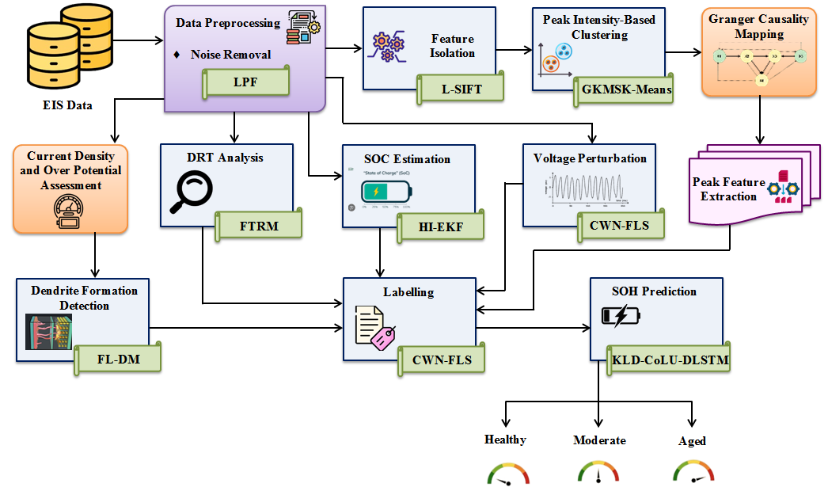
Figure 1: The block diagram of the proposed approach
A comprehensive EIS-based battery health monitoring framework is proposed by performing noise removal, feature extraction, and voltage perturbation analysis. Also, the core innovations, such as SOC estimation, dendrite detection, and feature isolation help to increase the lifetime of the batteries. Thus, the detailed mathematical version of the proposed work is given in the following sections.
  - EIS data
In the first step, EIS data of the lithium-ion batteries is gathered from the publically available source to train the proposed SOH prediction model. The collected EIS data helps to detect early signs of battery degradation.
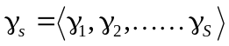 Where, 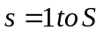 (1)
Here, depicts the number of input EIS data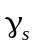. The collected EIS data encompasses time-series information, such as voltage, current, temperature, and internal resistance, thereby analyzing the internal behaviors of the lithium-ion batteries.
  - Data pre-processing
Next, the is pre-processed for noise removal to eradicate the noise by allowing frequencies below a nominal threshold value. The proposed work utilizes the Low-Pass Filtering (LPF) to perform noise removal.
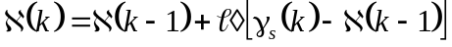 (2)
Where, 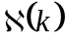depicts the filtered output at time, 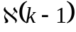denotes the previous output of the filter, and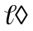indicates the smoothing factor. The noise removal aims to remove high-frequency noise in EIS data, thus enhancing the data quality and reliability.
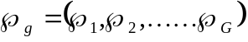 Here, 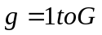 (3)
Where, illustrates the total number of pre-processed data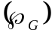.
  - Spectrum isolation
In this phase, the pre-processed data 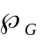is fed into the feature (spectrum) isolation to identify the dominant electrochemical features like transfer resistance and diffusion behavior. Frequency isolation is the task of isolating particular frequency components from an EIS signal. The proposed work establishes the L-STFT to isolate the spectrums in the pre-processed data. The Short-Time Fourier Transform (STFT) effectively captures the localized frequency information over time. However, the improper window size mainly affects the quality of the isolated spectrums. Therefore, the proposed method employs the Lunacek function to select the appropriate window size.
(4)
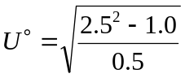 (5)
Where,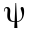depicts the window size, and 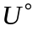denotes the Lunacek parameter.
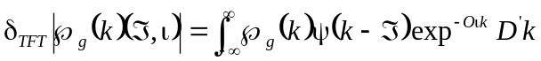 (6)
Here, 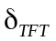demonstrates the STFT, depicts the time frame index, illustrates the angular frequency,  indicates the constant value, and 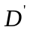exhibits the differential parameter.
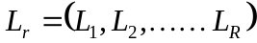 Here, 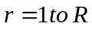 (7)
Where, depicts the number of isolated spectrums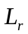. Spectrum isolation enhances the feature clarity by eliminating noise and irrelevant components, thus resulting in accurate prediction.
  - Peak intensity-based clustering
Subsequently, the proposed GKMSK-means algorithm is employed to perform peak intensity-based clustering in , thereby highlighting the subtle signal variations. The existing K-means had simplicity and flexibility in data grouping based on their similarity. However, the traditional distance calculation causes outliers and incorrect clustering. Also, the poor centroid initialization leads to suboptimal clustering outcomes. Hence, the proposed work employs the Gauss-Kuzmin distribution function and maximum shifting correlation distance to improve the clustering quality.
- Firstly, the number of clusters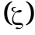 is determined based on the data analysis or domain knowledge.
- Thereafter, the initial cluster centroid 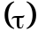is selected from the available data points using the Gauss-Kuzmin distribution function.
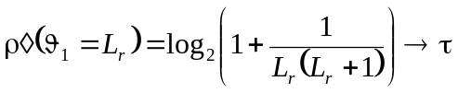 (8)
Where, 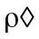demonstrates the probability factor, 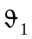indicates the first partial coefficient, and 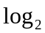illustrates the logarithmic function.
- Subsequently, the maximum shifting correlation distance is used to calculate the distance between the data points and the centroid.
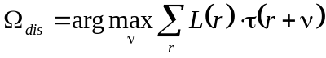 (9)
Here, 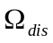depicts the distance value, 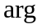represents the argument function, and denotes the lag.
      - Next, the data points are assigned to the nearest centroid. Further, the new centroid is recomputed by taking the mean of all data points in each cluster.
- Thus, the clustering process is repeated iteratively until the desired number of clusters is obtained. Here, similar EIS signal spectrums are grouped to upgrade the performance of the SOH estimation. The peak intensity-based clustered spectrums are mentioned as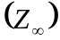.
  - Granger causality mapping
Afterward, the Granger Causality Mapping (GCM) is done in 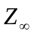to identify the peaks in the EIS spectrum that correspond to internal battery defects. The GCM is a statistical technique used to predict future values based on past values using the Vector Auto-Regressive (VAR) model. In the context of LIB, the clustered peak intensities and target variables (known defect indicators) are initially determined. Thereafter, the Granger causality test is done to map each clustered peak intensity to the defect indicators.
Primarily, the univariate VAR is estimated to reveal how well the defect indicator predicts itself. The univariate VAR model utilizes only one variable’s past values to estimate its own future values.
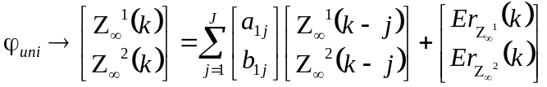 (10)
Afterward, the bivariate VAR model is calculated to evaluate whether past values of the EIS peak help to predict the defect indicators. The bivariate VAR model 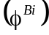uses a second variable (EIS peak intensity) to improve the prediction of the primary variable.
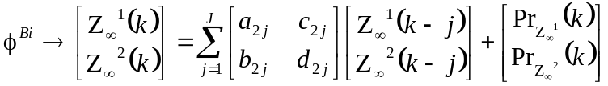 (11)
Where, 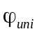indicates the univariate VAR model, 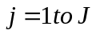denotes the lagged coefficients, 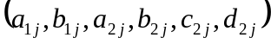illustrate the constant coefficients, 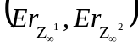exhibit the prediction errors of the univariate model, and 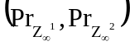indicate the prediction errors of the bivariate model.
Next, the variances of the errors 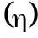are used to analyze the Granger causality relationship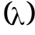 between two time-series EIS data.
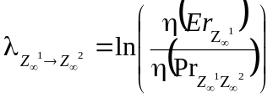 (12)
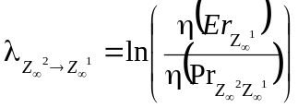 (13)
Here, 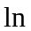depicts the logarithm function. Here, the 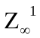is the granger cause to 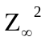when 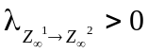. In the same manner, the is the granger cause to when 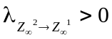. Finally, the EIS peaks are mapped to the internal defects. Thus, the mapped data is illustrated as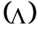.
  - Peak-based feature extraction
From , the essential features, such as peak amplitude, peak frequency, phase angle at peak, peak skewness, peak kurtosis, and peak shape are extracted.
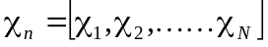 Here, 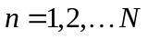 (14)
Where, exhibits the number of extracted peak-based features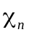.
  - Debye relaxation time analysis
Meanwhile, the debye relaxation time of the lithium-ion batteries is analyzed from the pre-processed data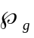 using FTRM to improve the performance of the batteries. In basic, DRT is a crucial factor used to analyze the SOH estimation of battery. The DRT reveals how the battery’s internal state responds to changes, such as voltage fluctuation. Due to the maximum age of the battery, the battery takes a longer time to recover after voltage fluctuations. The recovery time after disruption refers to the debye relaxation time. Therefore, the DRT analysis is crucial to estimate the SOH by considering the time-sensitive aging factor. The prevailing Tikhonov Regularization (TR) provides stable and accurate detection while mitigating overfitting issues. However, the existing TR had high computational complexity owing to the shrinkage of coefficients. Therefore, the proposed work employs the foxholes function to fix the model coefficients.
Primarily, the battery impedance is computed by considering the voltage and current measurements. Then, the impedance 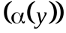is decomposed into ohmic resistance 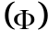and distribution of relaxation time 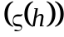, which shows how various processes within the battery relax over time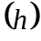.
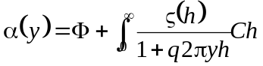 (15)
Where, indicates the imaginary part, denotes the frequency, and represents the differential factor. Afterward, the integral term is converted into a matrix problem 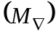to map the DRT to the measured impedance.
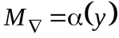 (16)
Here, indicates the vector of coefficients, which is calculated by using the foxholes function.
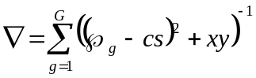 (17)
To stabilize the inversion, the Tikhonov regularization 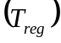is employed in the proposed work.
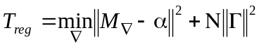 (18)
Where, indicates the regularization term, and anddepict the constant values. Finally, the DRT 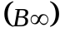is identified by analyzing the time corresponding to the largest peak in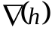.
The pseudo-code of the proposed FTRM is shown below,
Input: Pre-processed data
Output: DRT
Begin
Initialize,,and
For 1 to each do,
Compute impedance
Decompose measured impedance,
Generate matrix problem
#vector of coefficients
Apply foxholes function
Activate tikhonov regularization
Identify based on
End For
Return
End
Further, the voltage perturbation analysis is done to increase the model’s efficacy.
  - Voltage perturbation analysis
Here, the voltage fluctuation is analyzed in the pre-processed data using the proposed CWN-FLS algorithm. The voltage fluctuation analysis helps to increase the model's robustness. The Fuzzy Logic System (FLS) is easy and understandable. Also, the FLS effectively handles complex problems. However, the FLS had computational overhead due to the lack of an advanced defuzzification scheme. Therefore, the proposed work establishes the cosine whitening normalization to convert the fuzzy data into a crisp value in the defuzzification unit. The proposed CWN-FLS involves steps, such as fuzzification, rule base, decision-making unit, and defuzzification.
In the fuzzification unit, the Gaussian membership function 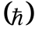is used to assign the membership degree to each crisp data, thereby obtaining the fuzzy set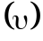.
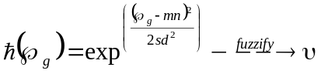 (19)
Where, and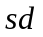depict the mean and standard deviation, respectively. To analyze the voltage fluctuations, the fuzzy rules 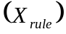are generated below,
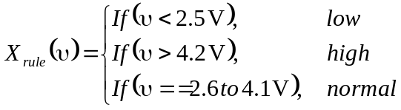 (20)
If the voltage value is less than 2.5 V, then it is considered as low risk. Likewise, if the voltage value is greater than 4.2 V, then it is assumed as high risk. Otherwise, the battery voltage is assumed as normal. In the decision-making unit, all the fuzzy operations are performed using a decision-making operator. Next, all the outcomes are aggregated to form a single value. Then, the defuzzification is performed via the cosine whitening normalization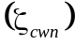.
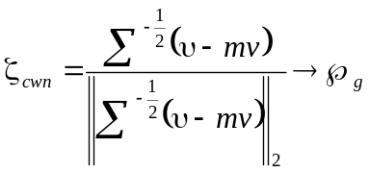 (21)
Where, indicates the mean vector. Thus, the voltage perturbation analyzed data is illustrated as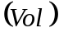.
  - Current density and over-potential assessment
In the same manner, the current density and over potential are calculated from the pre-processed data to analyze the dendrite formation. Generally, current density quantifies the electric current per unit area, whereas the over potential reveals the extra potential (voltage) beyond the thermodynamic equilibrium.
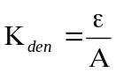 (22)
Where, 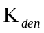denotes the current density, depicts the current, and illustrates the electrode surface area.
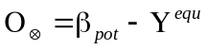 (23)
Here, 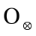depicts the over-potential, 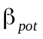implies the actual applied electrode potential, and 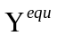exhibits the thermodynamic equilibrium potential.
  - Dendrite formation detection
Next, andare subjected to dendrite formation detection, where the lithium dendrite growth is identified. The proposed work utilizes the FL-DM to detect the dendrite formation.
- Initially, Fick’s laws are used to derive the governing equations for electrochemical diffusion processes. Thereafter, the battery structure, initial lithium-ion concentration, and boundary conditions are defined.
- Next, the current density is applied to simulate ion depletion. Here, high local currents indicate the potential for dendrite growth.
- Similarly, the effect of over-potential is analyzed to reveal its influence on ion deposition and diffusion rates. Subsequently, the numerical solvers are employed to solve the governing equations.
- Then, the indicators are monitored by outlining the sharp ion concentration drops, high electric fields, and current density spikes. Further, the dendrite formation is identified by considering the pre-defined threshold values.
The dendrite formation detection helps to prevent short circuits and battery degradation. Thus, the dendrite formation detected outcome is mentioned as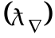.
  - SOC estimation
Additionally, the SOC is estimated from the pre-processed data by using the Hermite Interpolation Extended Kalman Filter (HI-EKF) to improve the model accuracy. The Extended Kalman Filter (EKF) enables real-time recursive estimation of SOC. However, EKF heavily relies on first-order Taylor series expansion to linearize nonlinear models. Therefore, the Hermite interpolation is employed to improve the system efficiency. Thus, the design of the proposed HI-EKF is given in Figure 2.
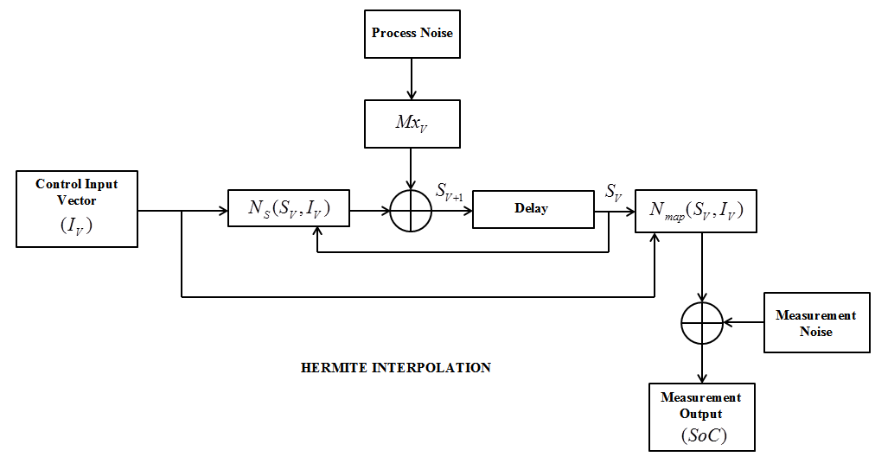
Figure 2: The HI-EKF’s structure
In Figure 2, 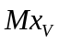depicts the noise matrix and 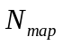illustrates the measurement noise. The control input vector is assumed as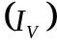. Next, the Hermite interpolation is computed.
(24)
Where, 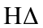depicts the Hermite interpolating polynomial, 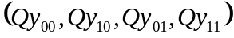indicate the Hermite basis functions, 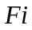exhibits the non-linear function, and 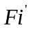specifies the derivative value.
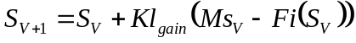 (25)
Where, 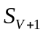demonstrates the updated state estimate at the time, 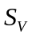indicates the predicted state estimate, 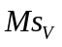depicts the measurement, and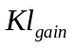indicates the Kalman gain. Thus, the estimated SOC is shown as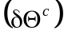.
  - Labelling
In this step, the labelling is done by considering the information related to DRT analysis, dendrite probability, SOC, peak features , and voltage stress using the proposed CWN-FLS. The mathematical modelling of the proposed CWN-FLS is given in Section 3.8. Further, the fuzzy rules 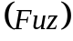for labelling are given below,
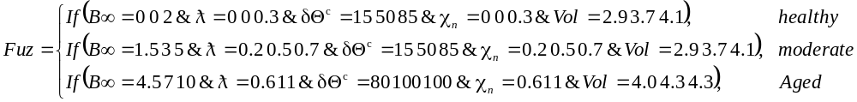 (26)
Likewise, the fuzzy rules are created for maximum combinations of the various factors. After labelling, the proposed SOH prediction model is trained. During testing, the above-mentioned factors are directly given to the SOH estimation module.
  - SOH prediction
Here, the proposed KLD-CoLU-DLSTM is employed to estimate the SOH of lithium-ion batteries, thus enhancing the battery maintenance schemes. The existing Deep Long Short Term Memory (DLSTM) effectively captures long-range dependencies in sequential data. However, the DLSTM had overfitting issues and vanishing gradient issues. Therefore, the proposed work introduces the Kullback-Leibler Divergence (KLD) regularization and Complementary Log-Unit (CoLU) activation function. Thus, the architecture of the proposed KLD-CoLU-DLSTM is given in Figure 3.

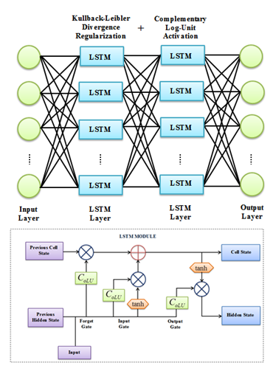
Figure 3: The structural design of the proposed KLD-CoLU-DLSTM
The KLD-CoLU-DLSTM includes the input layer, stacked LSTM layers, and output layer. Initially, the inputs 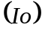, such as DRT analysis, dendrite probability, SOC, peak features , and voltage stressare transmitted to the stacked LSTM layers.
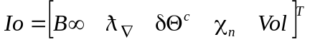 (27)
To mitigate the overfitting issues, the proposed work introduces KLD regularization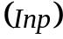.
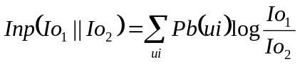 (28)
Where, 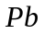illustrates the probability function and 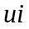depicts the number of entities. Here, the proposed work introduces the CoLU activation function 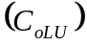to improve the classifier performance.
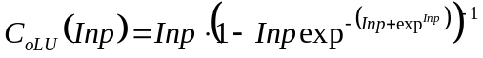 (29)
Then, the LSTM layers include the input gate, forget gate, and output gate. Basically, the input gate captures the relevant information that is required to pass through the further layers.
(30)
Where, 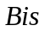denotes the bias, 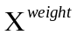represents the weight value, 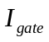illustrates the input gate, and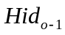exhibits the previous hidden state.
Likewise, the forget gate 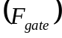is used to eliminate irrelevant information from the cell state.
(31)
Also, the output gate 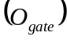highlights the important information that needs to be presented as an outcome.
(32)
Finally, the hidden state 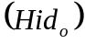is expressed below,
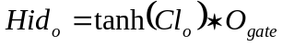 (33)
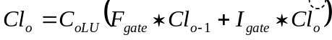 (34)
Where, 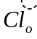demonstrates the candidate cell state,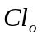denotes the cell state, and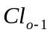illustrates the previous cell state. Thus, the output layer 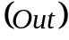classifies the SOH of the battery into healthy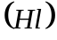, moderate 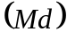, and aged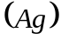.
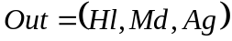 (35)
The pseudo-code of the proposed KLD-CoLU-DLSTM is given below,
Input:
Output: SOH prediction
Begin
Initialize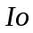,,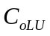and
For 1 to each input do,
Assume inputs
Regularize
Activate CoLU function,
Perform input gate,
Execute forget gate,
Evaluate output gate
Execute hidden state
Classify SOH
End For
Return
End

Overall, the proposed methodology improves the efficiency of the lithium-ion batteries.
- RESULTS AND DISCUSSION
In this section, the performance assessment and comparative validation are carried out to evaluate the robustness and efficiency of the proposed framework. The proposed methodology is implemented on the working platform of MATLAB.
  - Dataset description
The proposed work is evaluated by using the Bat-Data (BD), and the source link of the dataset is mentioned under the reference section. The BD includes the EIS data that aids in identifying the internal behaviors of the lithium-ion batteries. Essentially, the BD encompasses the data from four lithium-ion batteries (5, 6, 7, and 18). The experimentation is done at room temperature for three operational profiles (charging, discharging, and impedance measurements). Further, the dataset is organized into MATLAB .mat files. The .mat files involve time-series data of the battery’s operational cycles. Moreover, the data encompasses measurements like voltage, current, temperature, and internal resistance. Here, the dataset is divided into two sub-sets, namely the training set (80%) and the testing set (20%).
  - Performance evaluation for DRT analysis
To showcase the model’s dominance in DRT analysis, the performance of the proposed FTRM is compared with the existing algorithms like TRM, Singular Value Decomposition (SVD), ElasticNet, and Lasso.
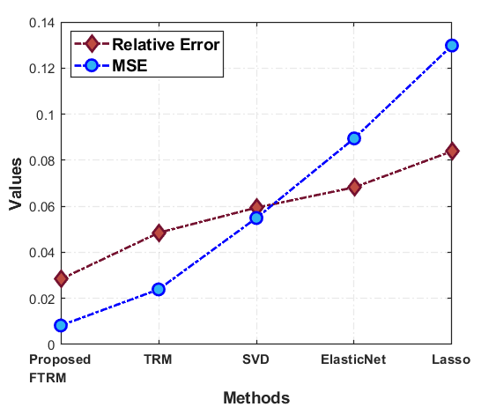
Figure 4: Performance validation of the proposed FTRM
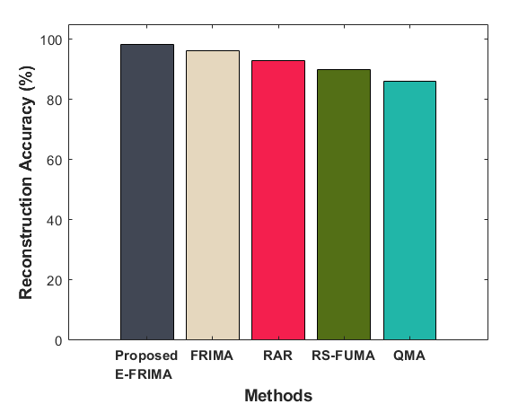
Figure 5: Reconstruction accuracy analysis
In Figures 4 and 5, the performance investigation for DRT analysis is presented regarding relative error, Mean Squared Error (MSE), and reconstruction accuracy. The proposed FTRM obtained relative error, MSE, and reconstruction accuracy of 0.02834, 0.00822, and 98.2034%, respectively. The performance of the proposed algorithm is improved through the foxholes function. However, the conventional algorithms achieved an average relative error, MSE, and reconstruction accuracy of 0.06500, 0.07451, and 91.2070%, respectively. Thus, the analysis outcomes revealed the supremacy of the proposed work in DRT analysis.

  - Empirical assessment for labelling
The performance analysis of the proposed CWN-FLS and existing algorithms like FLS, trapezoidal FLS, sigmoid FLS, and Adaptive-Neuro Fuzzy Inference System (ANFIS) is done to prove the model’s efficiency in labelling.
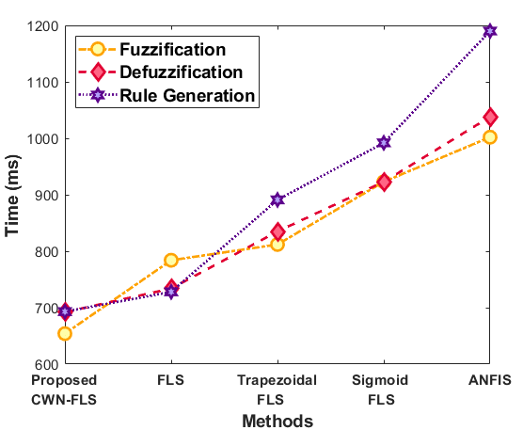
Figure 6: Performance assessment of the proposed CWN-FLS
In Figure 6, quality metrics like Fuzzification Time (FT), Defuzzification Time (DT), and Rule Generation Time (RGT) are considered to validate the performance of the proposed CWN-FLS and conventional approaches. The proposed CWN-FLS achieved FT, DT, and RGT of 654ms, 692ms, and 693ms, respectively. But, the conventional ANFIS took 1190ms to generate the fuzzy if-then rules. Also, the conventional ANFIS consumed 1002ms and 1038ms to perform fuzzification and defuzzification, respectively. Hence, the low time complexity of the proposed work was evidenced.
  - Experimental validation for SOC estimation
Here, the performance analysis is carried out to showcase the model’s significance in SOC estimation.
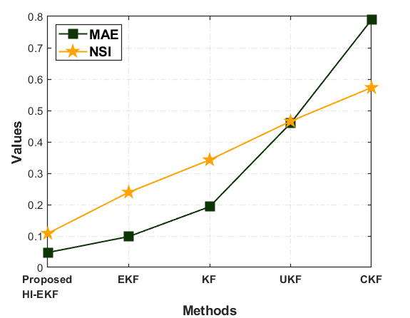
Figure 7: Performance assessment of the proposed HI-EKF
Figure 7 compares the Mean Absolute Error (MAE) and Noise Sensitivity Index (NSI) of the proposed HI-EKF and existing algorithms like EKF, Kalman Filter (KF), Unscented Kalman Filter (UKF), and Cubature Kalman Filter (CKF). The proposed HI-EKF had 0.0473 MAE and 0.1083 NSI. The presence of Hermite Interpolation (HI) helped to improve the model’s performance. However, the prevailing EKF obtained MAE and NSI of 0.0982 and 0.2394, respectively. Therefore, the proposed methodology had impressive performance in SOC estimation when compared to the existing algorithms.
  - Performance evaluation for SOH prediction
To showcase the efficiency of the proposed KLD-CoLU-DLSTM in SOH prediction, performance validation is carried out.

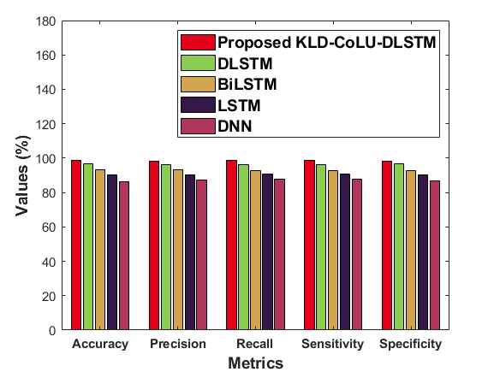
Figure 8: Performance validation of the proposed KLD-CoLU-DLSTM
In Figure 8, the performance of the proposed KLD-CoLU-DLSTM is validated by comparing it with several conventional classifiers, such as DLSTM, Bidirectional LSTM (BiLSTM), LSTM, and Deep Neural Network (DNN) with respect to quantitative metrics. The proposed KLD-CoLU-DLSTM achieved accuracy, precision, recall, sensitivity, and specificity of 98.94%, 98.03%, 98.54%, 98.34%, and 98.54%, respectively. Nevertheless, the existing classifiers had poor outcomes owing to the vanishing gradient issue. Therefore, the proposed KLD-CoLU-DLSTM had higher supremacy in SOH prediction owing to the presence of CoLU activation.
Table 1: RMSE analysis
Techniques | RMSE
Proposed KLD-CoLU-DLSTM | 0.0748
DLSTM | 0.14339
BiLSTM | 0.249
LSTM | 0.398
DNN | 0.489
The Root Mean Squared Error (RMSE) of the proposed KLD-CoLU-DLSTM and existing classifiers is analyzed in Table 1. The proposed KLD-CoLU-DLSTM obtained an RMSE of 0.0748, whereas the existing DLSTM had 0.14339 RMSE. Hence, the proposed work had more robustness in SOH estimation.
  - Performance assessment for clustering
Additionally, the performance of the proposed GKMSK-means is evaluated by comparing it with existing techniques, such as K-means, Hierarchical Clustering (HC), Density-Based Spatial Clustering of Applications with Noise (DBSCAN), and Fuzzy C Means (FCM).

Table 2: Clustering performance analysis
Algorithms | Silhouette Score | Davies-Bouldin Index
Proposed GKMSK-means | 0.9739 | 0.16537
K-means | 0.923 | 0.2847
HC | 0.893 | 0.381
DBSCAN | 0.852 | 0.4739
FCM | 0.817 | 0.6578
Table 2 shows the performance analysis of the proposed GKMSK-means and existing approaches. The proposed GKMSK-means achieved silhouette score and davies-bouldin index of 0.9739 and 0.16537, respectively. However, the conventional FCM had a 0.817 silhouette score and a 0.6578 davies-bouldin index. Thus, the proposed methodology had better performance due to the utilization of maximum shifting correlation distance.
  - Numerical evaluation for feature isolation
Further, the performance analysis for feature isolation is presented in this section.
Table 3: SNR analysis
Methods | SNR(dB)
Proposed L-STFT | 33
STFT | 28
CWT | 24
DWT | 20
LWT | 18
Table 3 illustrates the empirical analysis of the proposed L-STFT and conventional algorithms like STFT, Continuous Wavelet Transform (CWT), Discrete Wavelet Transform (DWT), and Lifting Wavelet Transform (LWT). The proposed L-STFT obtained an SNR of 33dB, whereas the prevailing LWT had 18dB SNR. Therefore, the proposed work achieved superior results in feature isolation owing to the inclusion of the lunacek function.
  - Comparative assessment of the proposed work
Here, the comparative analysis of the proposed methodology is done to prove the model’s supremacy.
Table 4: Comparative validation
Authors’ name | Algorithms | RMSE | Accuracy (%)
Proposed work | KLD-CoLU-DLSTM | 0.0748 | 98.94
(Li et al., 2023 a) | Fusion neural network model of Conv1d-SAM (one-dimensional convolutional neural network-Self-Attention Mechanism) | 7.35 | 72
(Jafari et al., 2024) | Deep learning fusion model (CNN and LSTM) | 0.094 | -
(Choi et al., 2024) | LSTM | 10.01 | -
(Venugopal et al., 2021) | Ensemble-ML | 0.189 | 94
(Teng et al., 2023) | Backpropagation Neural Network (BPNN) and Long-Short-Term-Memory (LSTM) | 3.34 | -
The comparative analysis of the proposed work and related models is presented in Table 4. The proposed KLD-CoLU-DLSTM obtained RMSE and accuracy of 0.0748 and 98.94%, respectively. However, the traditional ensemble-ML (Venugopal et al., 2021) achieved RMSE and accuracy of 0.189 and 94%, respectively. Thus, the proposed work had impressive performance owing to the presence of CoLU activation function and KLD regularization.
- CONCLUSION
This article proposed a reliable EIS-based SOC and SOH estimation framework for lithium-ion batteries using DRT analysis and KLD-CoLU-DLSTM. The proposed work was specially designed to analyze the DRT of the lithium-ion batteries, thus increasing the battery maintenance performance. The proposed FTRM was implemented to analyze the DRT of the lithium-ion batteries. To precisely estimate the SOC, the proposed HI-EKF was incorporated in the proposed work. Moreover, the proposed CWN-FLS was established to perform model labelling with a 693ms rule generation time. Here, a novel KLD-CoLU-DLSTM was employed to accurately estimate the SOH of the lithium-ion batteries with 98.94% accuracy. Moreover, the core innovations, such as peak intensity-based clustering, voltage perturbation analysis, and dendrite formation detection aided in enhancing the battery reliability. The proposed FTRM obtained relative error and MSE of 0.02834 and 0.008223, respectively. Overall, the experimental outcomes proved that the proposed approach had high reliability and minimum complexity. Overall, the experimental outcomes proved that the proposed approach had high reliability and minimum complexity. But, this work heavily focused on DRT analysis.
Future scope: In the future, this work will focus on interfacial resistance estimation through relaxation time modelling, thereby improving the model’s performance.
References:
Dataset: https://www.kaggle.com/datasets/baruch100/bat-data?select=B0005.mat
Ayob, A., Ansari, S., Lipu, M. S. H., Hussain, A., & Saad, M. H. M. (2022). SOC, SOH and RUL Estimation for Supercapacitor Management System: Methods, Implementation Factors, Limitations and Future Research Improvements. Batteries, 8(10), 1–29. https://doi.org/10.3390/batteries8100189
Bourelly, C., Vitelli, M., Milano, F., Molinara, M., Fontanella, F., & Ferrigno, L. (2023). EIS-Based SoC Estimation: A Novel Measurement Method for Optimizing Accuracy and Measurement Time. IEEE Access, 11, 91472–91484. https://doi.org/10.1109/ACCESS.2023.3308029
Buchicchio, E., De Angelis, A., Santoni, F., Carbone, P., Bianconi, F., & Smeraldi, F. (2023). Battery SOC estimation from EIS data based on machine learning and equivalent circuit model. Energy, 283, 1–9. https://doi.org/10.1016/j.energy.2023.128461
Chan, H. S., Dickinson, E. J. F., Heins, T. P., Park, J., Gaberšček, M., Lee, Y. Y., Heinrich, M., Ruiz, V., Napolitano, E., Kauranen, P., Fedorovskaya, E., Moškon, J., Kallio, T., Mousavihashemi, S., Krewer, U., Hinds, G., & Seitz, S. (2022). Comparison of methodologies to estimate state-of-health of commercial Li-ion cells from electrochemical frequency response data. Journal of Power Sources, 542, 1–14. https://doi.org/10.1016/j.jpowsour.2022.231814
Choi, Y., Yun, J., & Jang, P. (2024). A Deep Learning Approach for State of Health Estimation of Lithium-Ion Batteries Based on Differential Thermal Voltammetry. IEEE Access, 12, 89921–89932. https://doi.org/10.1109/ACCESS.2024.3419837
Dini, P., Colicelli, A., & Saponara, S. (2024). Review on Modeling and SOC/SOH Estimation of Batteries for Automotive Applications. Batteries, 10(1), 1–37. https://doi.org/10.3390/batteries10010034
Fan, M., Geng, M., Yang, K., Zhang, M., & Liu, H. (2023). State of Health Estimation of Lithium-Ion Battery Based on Electrochemical Impedance Spectroscopy. Energies, 16(8), 1–14. https://doi.org/10.3390/en16083393
Huang, Z., Best, M., Knowles, J., & Fly, A. (2022). Adaptive Piecewise Equivalent Circuit Model With SOC/SOH Estimation Based on Extended Kalman Filter. Loughborough University, 1–13. https://doi.org/10.1109/TEC.2022.3218613
Iurilli, P., Brivio, C., Carrillo, R. E., & Wood, V. (2022). Physics-Based SoH Estimation for Li-Ion Cells. Batteries, 8(11), 1–18. https://doi.org/10.3390/batteries8110204
Jafari, S., Kim, J., & Byun, Y. C. (2024). A novel fusion-based deep learning approach with PSO and explainable AI for batteries State of Charge estimation in Electric Vehicles. Energy Reports, 12, 3364–3385. https://doi.org/10.1016/j.egyr.2024.09.010
Jin, L., Bereck, F. P., Granwehr, J., & Scheurer, C. (2025). Extending Equivalent Circuit Models for State of Charge and Lifetime Estimation. Electrochemical Science Advances, 1–11. https://doi.org/10.1002/elsa.202400024
Kim, J., & Kowal, J. (2021). A method for monitoring state-of-charge of lithium-ion cells using multi-sine signal excitation. Batteries, 7(4), 76. https://doi.org/10.3390/batteries7040076
Kurzweil, P., Scheuerpflug, W., Frenzel, B., Schell, C., & Schottenbauer, J. (2022). Differential Capacity as a Tool for SOC and SOH Estimation of Lithium Ion Batteries Using Charge/Discharge Curves, Cyclic Voltammetry, Impedance Spectroscopy, and Heat Events: A Tutorial. Energies, 15(13), 1–21. https://doi.org/10.3390/en15134520
Li, D., Yang, D., Li, L., Wang, L., & Wang, K. (2022). Electrochemical Impedance Spectroscopy Based on the State of Health Estimation for Lithium-Ion Batteries. Energies, 15(18), 1–26. https://doi.org/10.3390/en15186665
Li, J., Zhao, S., Miah, M. S., & Niu, M. (2023 a). Remaining useful life prediction of lithium-ion batteries via an EIS based deep learning approach. Energy Reports, 10, 3629–3638. https://doi.org/10.1016/j.egyr.2023.10.030
Li, Y., Maleki, M., & Banitaan, S. (2023 ). State of health estimation of lithium-ion batteries using EIS measurement and transfer learning. Journal of Energy Storage, 73, 1–12. https://doi.org/10.1016/j.est.2023.109185
Liu, Y., Wang, L., Li, D., & Wang, K. (2023). State-of-health estimation of lithium-ion batteries based on electrochemical impedance spectroscopy: a review. Protection and Control of Modern Power Systems, 8(1), 1–17. https://doi.org/10.1186/s41601-023-00314-w
Mc Carthy, K., Gullapalli, H., Ryan, K. M., & Kennedy, T. (2022). Electrochemical impedance correlation analysis for the estimation of Li-ion battery state of charge, state of health and internal temperature. Journal of Energy Storage, 50, 1–10. https://doi.org/10.1016/j.est.2022.104608
Mustafa, H., Bourelly, C., Vitelli, M., Milano, F., Molinara, M., & Ferrigno, L. (2024). SoC estimation on Li-ion batteries: A new EIS-based dataset for data-driven applications. Data in Brief, 57, 1–15. https://doi.org/10.1016/j.dib.2024.110947
Padder, S. G., Ambulkar, J., Banotra, A., Modem, S., Maheshwari, S., Jayaramulu, K., & Kundu, C. (2025). Data-Driven Approaches for Estimation of EV Battery SoC and SoH: A Review. IEEE Access, 13, 35048–35067. https://doi.org/10.1109/ACCESS.2025.3539528
Peng, J., Meng, J., Du, X., Cai, L., & Stroe, D. I. (2023). A Fast Impedance Measurement Method for Lithium-Ion Battery Using Power Spectrum Property. IEEE Transactions on Industrial Informatics, 19(7), 8253–8261. https://doi.org/10.1109/TII.2022.3217474
Ruan, H., Sun, B., Jiang, J., Zhang, W., He, X., Su, X., Bian, J., & Gao, W. (2021). A modified-electrochemical impedance spectroscopy-based multi-time-scale fractional-order model for lithium-ion batteries. Electrochimica Acta, 394, 1–13. https://doi.org/10.1016/j.electacta.2021.139066
Shao, B., Zhong, J., Tian, J., Li, Y., Chen, X., Dou, W., Liao, Q., Lai, C., Lu, T., & Xie, J. (2025). State-of-Health Estimation of Lithium-Ion Batteries Based on Electrochemical Impedance Spectroscopy Features and Fusion Interpretable Deep Learning Framework. Energies, 18(6), 1–25. https://doi.org/10.3390/en18061385
Sun, X., Zhang, Y., Zhang, Y., Wang, L., & Wang, K. (2023). Summary of Health-State Estimation of Lithium-Ion Batteries Based on Electrochemical Impedance Spectroscopy. Energies, 16(1), 1–19. https://doi.org/10.1186/s41601-023-00314-w
Teng, J. H., Chen, R. J., Lee, P. T., & Hsu, C. W. (2023). Accurate and Efficient SOH Estimation for Retired Batteries. Energies, 16(3), 1–17. https://doi.org/10.3390/en16031240
Thomas, H., Weatherspoon, M. H., & Nelson, R. (2025). Localized EIS Data for Capacity and SOH Prediction With Neural Networks. Battery Energy, 1–10. https://doi.org/10.1002/bte2.20250006
Venugopal, P., Shankar, S. S., Jebakumar, C. P., Agarwal, R., Alhelou, H. H., Reka, S. S., & Golshan, M. E. H. (2021). Analysis of Optimal Machine Learning Approach for Battery Life Estimation of Li-Ion Cell. IEEE Access, 9, 159616–159626. https://doi.org/10.1109/ACCESS.2021.3130994
Xu, Z., Li, H., Yazdi, M., Ouyang, K., & Peng, W. (2022). Aging Characteristics and State-of-Health Estimation of Retired Batteries: An Electrochemical Impedance Spectroscopy Perspective. Electronics (Switzerland), 11(23), 1–29. https://doi.org/10.3390/electronics11233863
Zhang, M., Liu, Y., Li, D., Cui, X., Wang, L., Li, L., & Wang, K. (2023). Electrochemical Impedance Spectroscopy: A New Chapter in the Fast and Accurate Estimation of the State of Health for Lithium-Ion Batteries. Energies, 16(4), 1–16. https://doi.org/10.3390/en16041599
Zhang, S., Hosen, S., Kalogiannis, T., Mierlo, J. Van, & Berecibar, M. (2021). State of Health Estimation of Lithium-Ion Batteries Based on Electrochemical Impedance Spectroscopy and Backpropagation Neural Network. World Electric Vehicle Journal, 12(8), 1–14. https://doi.org/10.3390/en16083393

